**DAILY ONLINE ACTIVITIES SUMMARY**

|  |  |  |  |  |  |  |  |  |
| --- | --- | --- | --- | --- | --- | --- | --- | --- |
| **Date:** | **19/05/2020** | | | | | **Name:** | **NAIPUNYA VINOD NAIK** | |
| **Sem & Sec** | **IV SEM & A SECTION** | | | | | **USN:** | **4AL18CS050** | |
| **Online Test Summary** | | | | | | | | |
| **Subject** | | **DESIGN AND ANALYSIS OF ALGORITHMS** | | | | | | |
| **Max. Marks** | | **30** | | **Score** | | | **23** | |
| **Certification Course Summary** | | | | | | | | |
| **Course** | **INTRODUCTION TO HADOOP** | | | | | | | |
| **Certificate Provider** | | | **GREAT LEARNING ACADEMY** | | **Duration** | | | **5.5 HRS** |
| **Coding Challenges** | | | | | | | | |
| **Problem Statement:** A user will input two strings, and we find if one of the strings is a sub sequence of the other. Program prints “yes” if either the first string is a sub sequence of the second string or the second string is a sub sequence of the first string. Assume that, the length of the first string is smaller than or equal to the length of the second string.  **An expected output of the program:**  Input the first string tree Input the second string Computer science is awesome YES | | | | | | | | |
| **Status: EXECUTED** | | | | | | | | |
| **Uploaded the report in Github** | | | | | **YES** | | | |
| **If yes Repository name** | | | | | <https://github.com/naipunya-naik/lockdown-coding/blob/master/C%20CODING/subsequence.c> | | | |
| **Uploaded the report in slack** | | | | | **YES** | | | |

Online Test Details: (Attach the snapshot and briefly write the report for the same)

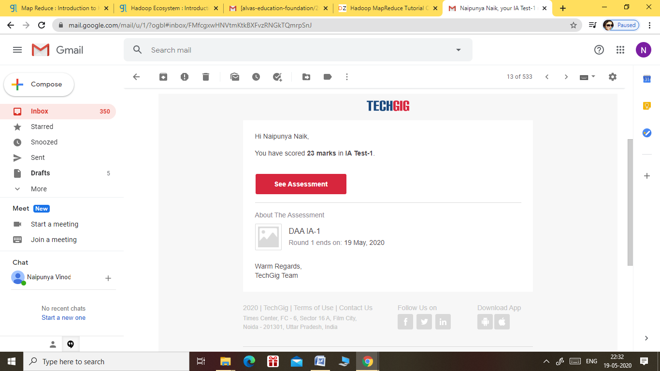

THE 1ST I.A TEST OF SUBEJCT DESIGN AND ANALYSIS OF ALGORITHMS WAS HELD ON 19 MAY 2020.

* SUBJECT:- DESIGN AND ANALYSIS OF ALGORITHMS
* SYLLABUS:- MODULE 1
* START TIME:- 9.15 AM
* END TIME:- 9.45 AM
* DURATION:- 30 MIN
* NO.OF QUESTIONS:- 30
* THE TEST COMPRISED 20 QUESTIONS OF 1 MARK AND 5 QUESTIONS OF 2 MARKS.

Certification Course Details: (Attach the snapshot and briefly write the report for the same)

CERTIFICATION COURSE NAME:- INTRODUCTION TO HADOOP

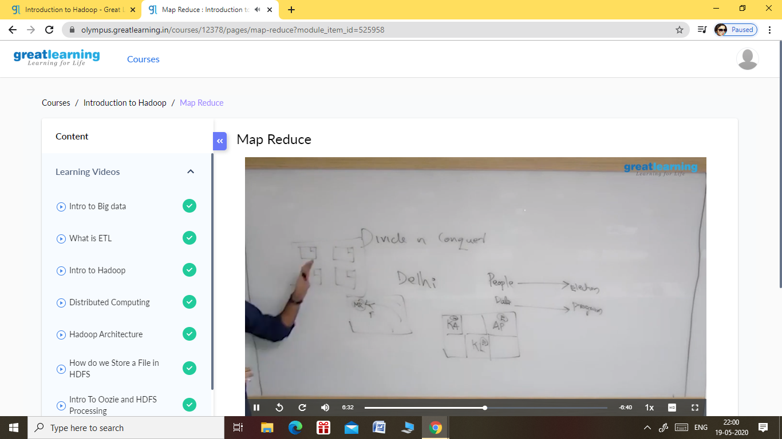

**Topics learnt on 19 may 2020:-**

* **Hadoop cluster hands on**

**1. Learnt how to analyse big data with hadoop**

**2. Learnt how to setup an apache cluster on hadoop.**

* **Hadoop ecosystem**

**1. Learnt about what is hadoop ecosystem?**

**2. Learnt about how to use hadoop tools for crunching big data.**

**3. Learnt about hadoop ecosystem and their components.**

* **Map reduce**

1. **Learnt about hadoop map reduce programming paradigm.**
2. **Learnt about map reduce real life examples.**
3. **Learnt about map reduce architecture.**

Coding Challenges Details: (Attach the snapshot and briefly write the report for the same)

PROBLEM STATEMENT:- A user will input two strings, and we find if one of the strings is a sub sequence of the other. Program prints “yes” if either the first string is a sub sequence of the second string or the second string is a sub sequence of the first string.  
Assume that, the length of the first string is smaller than or equal to the length of the second string.

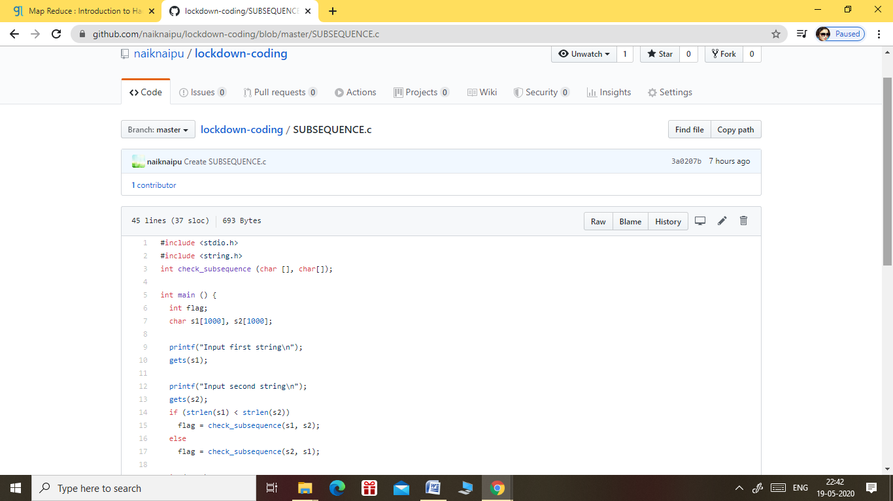

GITHUB REPOSITORY LINK:-

<https://github.com/naiknaipu/lockdown-coding/blob/master/SUBSEQUENCE.c>